**Topic:** Rybelsus Weight Loss in 2023 – Vigoursoul

**Focus keyword:** Rybelsus Weight Loss

**Meta Title:** Rybelsus Weight Loss in 2023 – Vigoursoul

**Meta Description:** Rybelsus weight loss side effects, dosage, uses, and more" (semaglutide). It is a prescription medication used to treat type 2 diabetes in people.

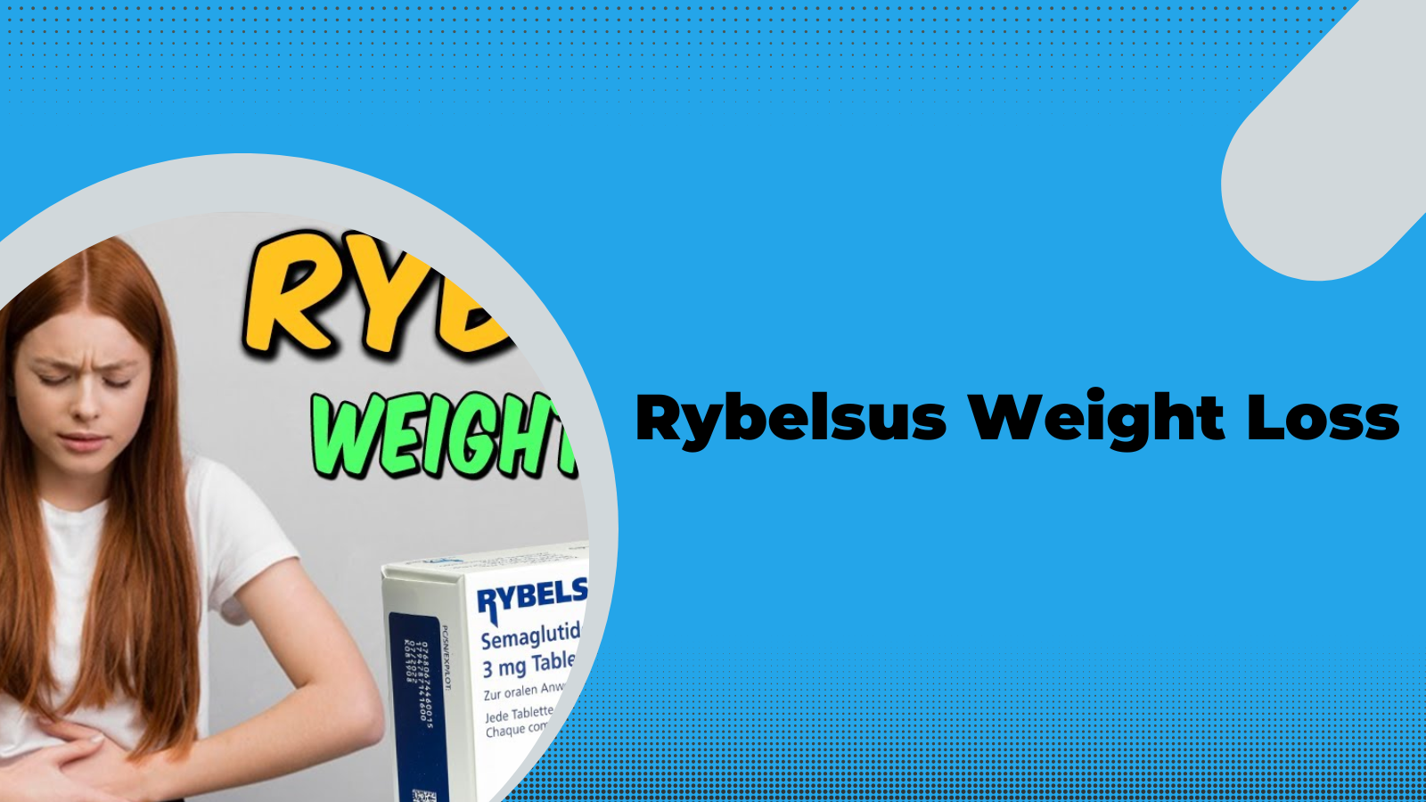

**Rybelsus Weight Loss** reduction. You may lose weight while taking [Rybelsus,](https://en.wikipedia.org/wiki/Semaglutide) but it is not a weight-loss medication. In tests, participants who weighed about 196 pounds (89 kilograms) on average and received the lowest dose of Rybelsus lost about 5 pounds (about 2 kilograms). This was observed throughout a 6-month period.

it is a prescription medication used to treat type 2 diabetes and can also aid in weight loss. It is not approved for the treatment of obesity. it works by reducing the amount of sugar your body absorbs from eating. This can result in calorie restriction and weight loss over time. If you are thinking about taking Rybelsus for weight loss, talk to your doctor about the dangers and benefits.

Approximately 70% of adult Americans are overweight or obese. Obesity and overweight are health disorders linked to some of the top causes of death, including heart disease, diabetes, and stroke. It is also linked to an increased risk of some types of cancer. Losing 5% to 10% of one's body weight by exercise and diet has been linked to a lower risk of cardiovascular disease in persons who are overweight or obese.

**Table of content:**

**Origin of Rybelsus:**

In December 2017, the injectable version named Ozempic was approved. In September 2019, a version which can be taken by mouth (Rybelsus) was approved, and in June 2021, a higher-dose injection sold under the brand name Wegovy for long-term weight management in adults was approved by the US Food and Drug Administration (FDA). In January of 2023, FDA gave Novo Nordisk permission to revise the label to indicate that oral Rybelsus can be used as a first-line treatment for adults with type 2 diabetes — meaning in people who have not previously taken another diabetes medication.

In 2020, semaglutide was the 129th most commonly prescribed medication in the United States, with more than 4 million prescriptions.

**Who Invented Rybelsus?**

Semaglutide, sold under the brand names Ozempic, Wegovy and Rybelsus, is an antidiabetic medication used for the treatment of type 2 diabetes and as anti-obesity medication for long-term weight management, developed by **Novo Nordisk** in 2012.

**Rybelsus basics:**

Sibelius is available in tablet form. You'll take it orally once a day, at least 30 minutes before your first meal. Semaglutide is the active ingredient of Rybelsus. It is a GLP-1 (glucagon-like peptide-1) agonist. This medication is not available in generic form. Instead, it is only available under the brand name Rybelsus. Continue reading to find out more about Rybelsus' side effects, cost, and other information.

**What is Rybelsus?**

If you have diabetes, your doctor may recommend Rybelsus. It is a prescription medication used to treat type 2 diabetes in people.

Rybelsus, together with good food and exercise, can help you regulate your blood sugar levels. See the "Is Rybelsus used for type 2 diabetes?" section for more details.

**How it works?**

GLP-1 is a natural hormone in your body that regulates your appetite and food intake by acting on your brain. Rybelsus helps you lose weight by acting like GLP-1 and decreasing your appetite and food intake.

**Rybelsus Weight Loss Reviews:**

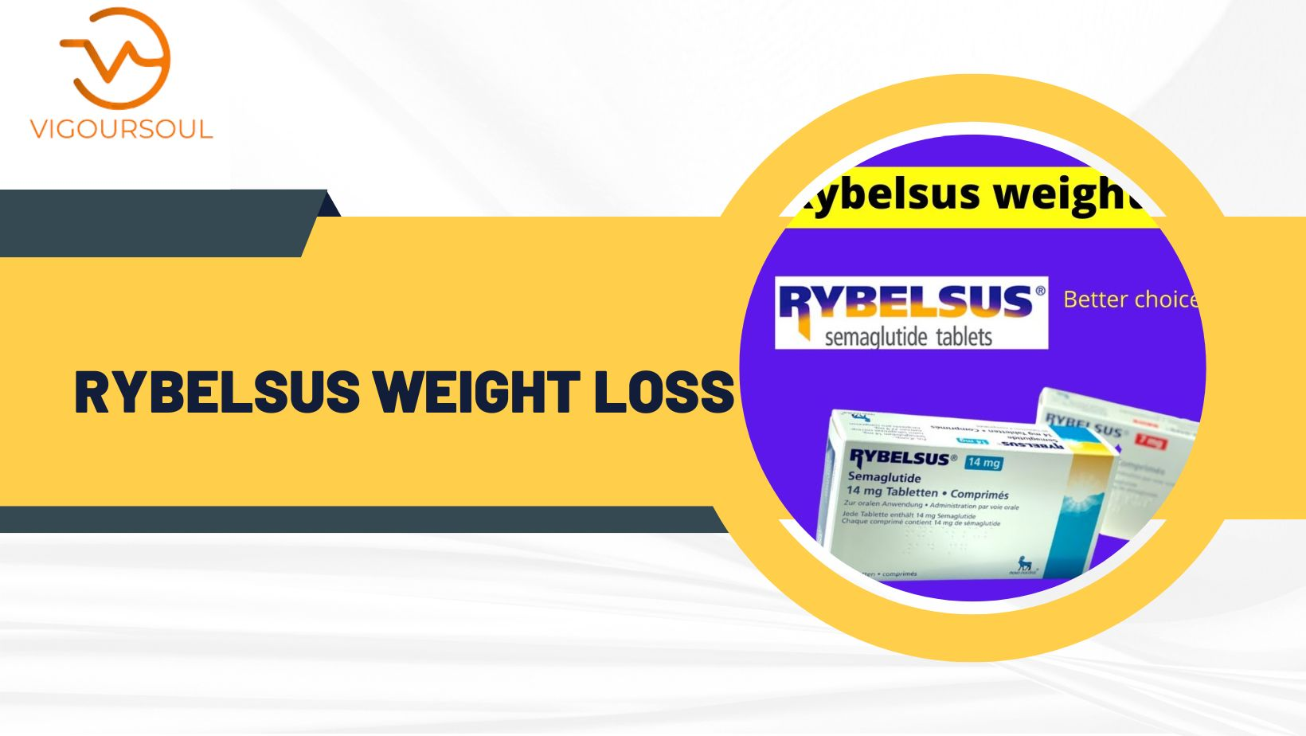

GLP-1s stimulate the pancreas to produce insulin after meals in order to lower blood sugar levels. They also bind to brain receptors to reduce appetite. These receptors release chemicals that assist reduce your desire to eat, so decreasing your hunger. GLP-1s are naturally occurring molecules that do not stay long in the human body. That is why, even though your body makes GLP-1s, taking them can help you lose weight.

It has assisted me in lowering my A1C from a peak of 9.7 to 5.1. I began with the 3mg and am now on the 14mg. I've been taking this medication since March, and while I did feel some nausea and moderate stomach discomfort, it went away after about a week. It has also assisted me in losing 50 pounds.

**Rybelsus Prescribed for Weight Loss:**

It is not authorized as a weight reduction supplement. Instead, it is used to maintain blood sugar levels in persons with type 2 diabetes in conjunction with appropriate food and exercise practices. Rybelsus may cause weight loss as a side effect. However, doctors would not prescribe this medicine for the purpose of decreasing weight.

**What are Rybelsus’ side effects?**

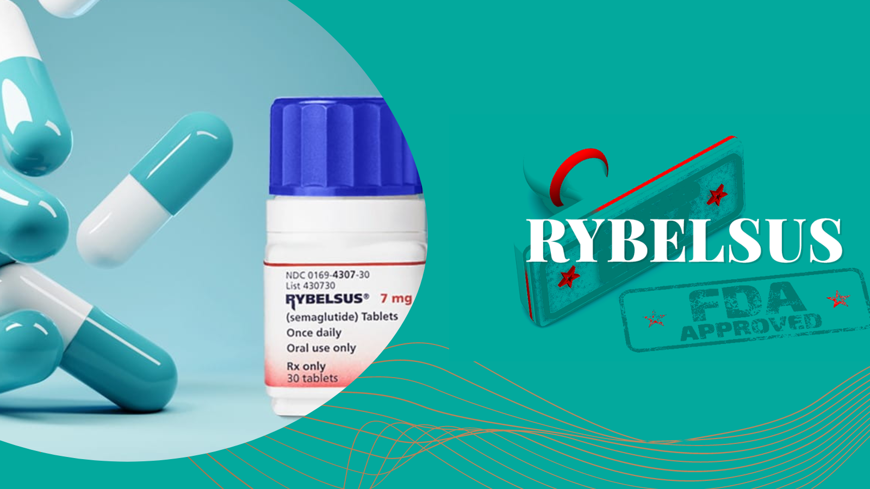

Rybelsus, like most medicines, can have mild to severe adverse effects. The following are some of the most prevalent adverse effects associated with Rybelsus. These lists do not cover all of the potential negative effects.

More information about Rybelsus side effects may be obtained from your doctor or pharmacist. They can also recommend strategies to lessen adverse effects.

**Mild Side Effects:**

The following is a list of some of the minor adverse effects that Rybelsus may induce. Talk to your doctor or pharmacist about any minor side effects, or read Rybelsus' drug information.

Mild Rybelsus side effects may include:

* Stomach ache
* Nausea
* Lack of appetite due to diarrhea
* Vomiting
* Constipation
* Weight reduction

When you first start using Rybelsus, you may have [nausea,](https://en.wikipedia.org/wiki/Nausea#:~:text=Nausea%20is%20a%20diffuse%20sensation,or%20back%20of%20the%20throat.) vomiting, and diarrhea. Mild side effects of many medications, on the other hand, may disappear within a few days or weeks. Consult your doctor or pharmacist if they become troublesome.

**How does Cause Rybelsus Weight Loss?**

* Rybelsus may promote weight reduction in a variety of ways. This drug decreases the rate at which your stomach empties, making you feel fuller and less hungry after eating. Rybelsus can induce stomach trouble, including nausea and vomiting, causing you to eat less than usual.
* Rybelsus targets GLP-1, a hormone that regulates hunger. Obese individuals’ hunger hormones have been shown in studies to be changed, which imply they may feel more hungry than thinner people.
* GLP-1 receptor agonists like Rybelsus appear to reestablish a hormone activation pattern more akin to lean people in obese patients.

**Tips to Lose Weight While Taking Rybelsus:**

To further boost your weight loss capabilities while taking Rybelsus, consider:

* Eating a balanced diet and being mindful of your added sugar intake. Added sugar can worsen insulin resistance, making it harder to control your blood sugar levels and lose weight.
* Being active for at least 30 minutes most days of the week improves insulin sensitivity and can help promote weight loss.
* Getting adequate sleep at night, which plays a role in hunger and fullness hormones, and insulin sensitivity.

### FAQS (Rybelsus Weight Loss)

**How effective is Rybelsus Weight Loss?**

Weight reduction. You may lose weight while using Rybelsus, but it is not a weight loss medicine. In tests, participants who weighed around 196 pounds (89 kilograms) on average and received the lowest dose of Rybelsus lost about 5 pounds (about 2 kilograms). This was observed throughout a 6-month period.

**Is Rybelsus used for Weight Loss?**

Rybelsus Weight Loss is not authorized as a weight reduction supplement. Instead, it is used to maintain blood sugar levels in persons with type 2 diabetes in conjunction with appropriate food and exercise practices. Rybelsus weight loss as a side effect. However, doctors would not prescribe this medicine for the purpose of decreasing weight.

**Does Rybelsus cause hair loss?**

Hair loss was not mentioned as a negative effect by Rybelsus patients in clinical investigations. Diabetes, on the other hand, may raise your chance of hair loss. Diabetes, in fact, can reduce hair growth and prevent new hair from developing. Diabetes patients are also given Rybelsus.

**Will I Have Hair loss with Rybelsus?**

That is unlikely. During Rybelsus research, no one had hair loss. Remember that Rybelsus is only used in patients with type 2 diabetes. In addition, some persons may experience hair loss as a result of this illness. Inform your doctor if you are experiencing hair loss while taking Rybelsus. They can provide suggestions on how to deal with this side effect.

**What Should I know about Stopping Rybelsus?**

You can stop taking Rybelsus if your doctor advises you to. However, consult with your doctor first. If you stop taking this medication, your blood sugar levels will no longer be regulated. Your doctor can determine if diet and exercise are sufficient to control your blood sugar levels or whether you will need to take a new diabetic medication.

**Conclusion:**

Rybelsus is a GLP-1 receptor agonist, a type 2 diabetes medicine. Because of its effect on stomach emptying and satiety hormones, the drug Rybelsus can cause weight reduction. Rybelsus is less successful in promoting weight reduction when compared to weight loss drugs.